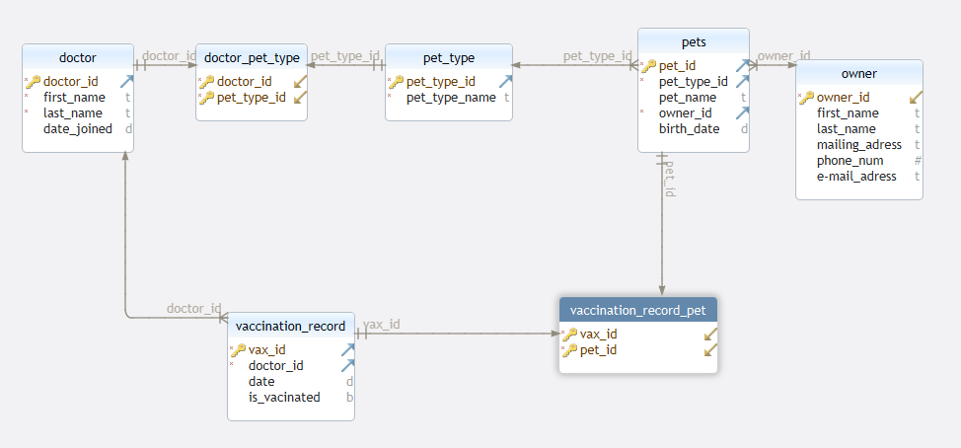

This is a data base designed for a veterinary section of a pet store where we will keep track of each pet, there owner, the type of pet they are, a list of the doctors, as well as a pets vaccination history. The sort of data stored for this is the owners details, the pets details including vaccination records, and the doctors details.

PK = Primary Key

FK = Foreign Key

|  |  |
| --- | --- |
| OWNER | |
| Attribute name | Data type and Constraints |
| Owner ID | INT NOT NULL, AUTO_INCRAMENT, PK |
| First_name | Varchar (30) |
| Last_name | Varchar (30) |
| Mailing_address | Varchar (100) |
| Phone_num | INT |
| e-mail_address | Varchar (100) |

|  |  |
| --- | --- |
| PETS | |
| Attribute name | Data type |
| Pet_Id | INT NOT NULL AUTO_INCRAMENT, PK |
| Pet_Type_Id | INT NOT NULL, FK |
| Pet_name | VARCHAR (30) |
| Owner_Id | INT NOT NULL, FK |
| Birth_date | DATE() |

|  |  |
| --- | --- |
| Doctor | |
| Attribute name | Data type |
| Doctor _Id | INT NOT NULL AUTO_INCRAMENT, PK |
| First_name | Varchar (30) |
| Last_name | Varchar (30) |
| Date_Joined | DATE |

|  |  |
| --- | --- |
| vaccination_record | |
| Attribute name | Data type |
| Vax_Id | INT NOT NULL AUTO_INCRAMENT, PK |
| Doctor _Id | INT NOT NULL, FK |
| Date | DATE |
| Is_vaccinated | Boolean |

|  |  |
| --- | --- |
| vaccination_record_pet | |
| Attribute name | Data type |
| Vax_Id | INT NOT NULL PK, FK |
| Pet_Id | INT NOT NULL, PK, FK |

|  |  |
| --- | --- |
| PET_TYPE | |
| Attribute name | Data type |
| Pet_Type_Id | INT NOT NULL AUTO_INCRAMENT, PK |
| Pet_Type_Name | VARCHAR(30) |

|  |  |
| --- | --- |
| Doctor_ PET_TYPE | |
| Attribute name | Data type |
| Doctor _Id | INT NOT NULL PK, FK |
| Pet_Type_Id | INT NOT NULL, PK, FK |